### ****Chapter: Low Back Pain****

#### ****I. Introduction****

Low back pain (LBP) remains a global health challenge affecting the lumbar spine. Studies report near-universal lifetime prevalence, estimated at 84-95% in industrialised nations **[1]**, making it the **second most common reason for physician visits** after upper respiratory infections. It is also the **leading cause of work-related disability among individuals under 45** **[2]**. While most cases resolve spontaneously, recurrence rates approach 40% within six months **[3]**.

#### ****II. Etiologies****

Low back pain (LBP) arises from a complex interplay of anatomical, biomechanical, and systemic factors. Contemporary classifications categorize etiologies into **mechanical**, **neuropathic**, **systemic**, and **referred visceral** causes **[4]**, though emerging research highlights genetic and microbiome interactions.

#### ****A. Mechanical Causes (85–90% of Cases)****

1. **Musculoligamentous Injuries**:
   * **Pathogenesis**: Acute strain from sudden movements or chronic overload due to poor posture. Microtears in muscles (erector spinae, multifidus) or ligaments (supraspinous, interspinous) trigger localized inflammation.
   * **Clinical Features**: Diffuse, non-radiating pain exacerbated by movement; tenderness on palpation.
   * **Classification**:
     + Acute: Post-traumatic (e.g., heavy lifting).
     + Chronic: Repetitive stress (e.g., sedentary occupations).
2. **Degenerative Spinal Disorders**:
   * **Intervertebral Disc Degeneration**:
     + **Pathogenesis**: Age-related proteoglycan loss → disc dehydration → reduced height and elasticity. This causes annular tears, disc bulging, and mechanical stress on facet joints.
     + **Stages**:
       1. Dysfunction (20–30 yrs): Radial fissures in annulus fibrosus.
       2. Instability (30–50 yrs): Progressive disc collapse, facet joint hypertrophy.
       3. Stabilization (>50 yrs): Osteophyte formation, spinal stiffening.
   * **Facet Joint Osteoarthritis**:
     + Synovial inflammation and cartilage erosion due to abnormal load-bearing. Pain localizes paravertebrally, worsens with extension/twisting.
   * **Spondylolysis/Spondylolisthesis**:
     + Pars interarticularis defects (L5 most common) → vertebral slippage → nerve root compression.
3. **Structural Abnormalities**:
   * **Spinal Stenosis**: Congenital or acquired narrowing of spinal canal/neuroforamina. Hypertrophied ligamentum flavum or facet joints compress cauda equina.
   * **Scoliosis/Kyphosis**: Asymmetric loading → accelerated disc/facet degeneration.

**Clinical Controversy**: *While disc degeneration is traditionally viewed as age-related, recent studies implicate collagen IX mutations (e.g., COL9A2) in early-onset cases **[5]*, challenging purely biomechanical models.*

#### ****B. Neuropathic Causes (5–10% of Cases)****

1. **Nerve Root Compression**:
   * **Disc Herniation**:
     + Protrusion: Disc material compresses roots (L5/S1 in 95% of cases).
     + Sequestered Fragment: Migrated nucleus pulposus causes severe radiculopathy.
   * **Foraminal Encroachment**: Osteophytes or synovial cysts impinge exiting roots (e.g., L4 radiculopathy).
2. **Peripheral Nerve Disorders**:
   * **Sciatic Nerve Entrapment**: Piriformis syndrome or pelvic masses.
   * **Peripheral Neuropathy**: Diabetes, vitamin B12 deficiency.

#### ****C. Systemic Causes (<5% of Cases)****

1. **Inflammatory Disorders**:
   * **Ankylosing Spondylitis (AS)**:
     + HLA-B27-associated enthesitis → sacroiliitis → bony fusion.
     + Hallmarks: Night pain, morning stiffness >30 min, improvement with activity.
   * **Rheumatoid Arthritis**: Synovitis targeting cervical spine (lumbar rare).
2. **Neoplastic Conditions**:
   * **Primary Tumors**: Osteoid osteoma, chordoma.
   * **Metastases**: Breast, prostate, lung cancers (vertebral body destruction).
3. **Infections**:
   * **Vertebral Osteomyelitis**: Staphylococcus aureus seeding via Batson’s plexus.
   * **Epidural Abscess**: Surgical emergency with fever and neurological deficits.
4. **Metabolic Bone Diseases**:
   * **Osteoporosis**: Vertebral compression fractures (T12-L2 most vulnerable).
   * **Paget’s Disease**: Disorganized bone remodeling → nerve compression.
5. **Trauma**:
   * **Vertebral Fractures**: Flexion-distraction injuries (e.g., Chance fractures).
   * **Soft-Tissue Contusions**: Paraspinal hematomas.

#### ****D. Referred Visceral Pain****

* **Renal/Urologic**: Pyelonephritis, nephrolithiasis (CVA tenderness, colicky pain).
* **Gastrointestinal**: Pancreatitis, aortic aneurysm (epigastric radiation).
* **Gynecologic**: Endometriosis, ovarian cysts (cyclical pelvic pain).

#### ****E. Risk Factor Interactions****

* **Biomechanical**:
  + Heavy lifting → 50% increased LBP risk (dose-dependent).
  + Whole-body vibration (e.g., truck driving) → disc nutrient deprivation.
* **Metabolic**:
  + Obesity (BMI >30) → inflammatory adipokines + mechanical load.
  + Smoking → reduced disc perfusion, impaired collagen repair.
* **Psychosocial**:
  + Depression/anxiety → amplified pain perception via limbic system dysregulation.
  + Job dissatisfaction → "pain behavior" perpetuation.

#### ****F. Emerging Etiologies****

1. **Genetic Predispositions**:
   * Collagen IX mutations (e.g., COL9A2) → disc degeneration susceptibility.
   * MMP-3 gene polymorphisms → accelerated matrix degradation.
2. **Microbiome Influence**:
   * Gut dysbiosis → systemic inflammation → AS progression.

**Clinical Pearl**: Mechanical causes dominate, but 10% of cases involve serious systemic pathology. Vigilance for "red flags" (e.g., weight loss, fever) is critical.

#### ****III. Pathogenesis****

* **Degenerative Disc Disease**: Proteoglycan loss in discs reduces hydration, leading to reduced shock absorption and disc height loss. Facet joint overload accelerates osteoarthritis.
* **Disc Herniation**: Nucleus pulposus protrusion compresses nerve roots (L5/S1 in 95% of cases), causing inflammation and edema.
* **Neuropathic Pain**: Nerve root compression induces pro-inflammatory cytokine release (TNF-α, IL-1β), demyelination, and ectopic nerve signaling.
* **Chronic Pain Mechanisms**: Central sensitization, glial cell activation, and psychosocial factors (depression, somatization) perpetuate pain.

#### ****IV. Diagnostic Evaluation****

Accurate diagnosis of low back pain (LBP) requires a systematic approach integrating clinical assessment, "red flag" identification, and judicious use of investigations. This expanded section details a stepwise diagnostic algorithm validated by international guidelines (NICE, ACP).

#### ****A. Clinical Assessment: History Taking****

##### ****1. Pain Characterization****

* **Temporal Pattern**:
  + Acute (<6 weeks): Often mechanical (muscle strain, disc herniation).
  + Subacute (6–12 weeks): Risk of chronicity if unmanaged.
  + Chronic (>12 weeks): Requires psychosocial evaluation.
* **Radiation Patterns**:
  + Radicular Pain (Sciatica): Shooting pain below knee (dermatomal distribution).
  + Referred Pain: Dull ache in buttocks/thighs (facets, SI joints).
* **Aggravating/Relieving Factors**:
  + Flexion relief → Spinal stenosis (neurogenic claudication).
  + Extension relief → Discogenic pain.
  + Night pain → Neoplasm or ankylosing spondylitis.

##### ****2. Neurologic Symptoms****

* **Motor Deficits**:
  + L5 root: Foot drop (unable to heel-walk).
  + S1 root: Unable to toe-walk.
* **Sensory Changes**:
  + Numbness/paresthesia in specific dermatomes:
    - L4: Medial ankle.
    - L5: Dorsum of foot.
    - S1: Lateral foot.
* **Autonomic Dysfunction**:
  + Urinary retention/incontinence → **Cauda Equina Syndrome (CES)**.

##### ****3. Psychosocial "Yellow Flags"****

* Depression (PHQ-9 score >10), job dissatisfaction, or pending litigation → Predict chronicity.

#### ****B. Physical Examination****

##### ****1. Core Components****

* **Gait Analysis**:
  + Antalgic gait (pain avoidance), steppage gait (foot drop).
* **Spinal Palpation**:
  + Tenderness over spinous processes (fracture), paraspinal muscles (strain), SI joints (sacroiliitis).
* **Range of Motion**:
  + Limited flexion → Disc herniation.
  + Limited extension → Facet arthropathy.

##### ****2. Neurologic Screening****

| ****Nerve Root**** | ****Motor Test**** | ****Reflex**** | ****Sensory Area**** |
| --- | --- | --- | --- |
| **L4** | Ankle dorsiflexion | Patellar | Medial ankle |
| **L5** | Great toe extension | None | Dorsum of foot |
| **S1** | Ankle plantar flexion | Achilles | Lateral heel |

##### ****3. Provocative Tests****

* **Straight Leg Raise (SLR)**:
  + Technique: Supine position, passive leg elevation.
  + Positive: Radicular pain <60° (sensitivity 91% for disc herniation).
  + Crossed SLR: Pain in affected leg when raising contralateral leg (specificity 90%).
* **Femoral Nerve Stretch Test**:
  + Prone knee flexion reproducing anterior thigh pain (L2–L4 radiculopathy).
* **Schober Test**:
  + <5 cm lumbar expansion on flexion → Ankylosing spondylitis.

#### ****C. Red Flags: Systematic Identification****

Red flags indicate urgent pathology requiring ≤24-hour intervention.

| ****Red Flag**** | ****Possible Etiology**** | ****Action**** |
| --- | --- | --- |
| **Bowel/bladder dysfunction** | Cauda equina syndrome | Emergency MRI + neurosurgery consult |
| **Saddle anesthesia** | Cauda equina syndrome | As above |
| **Progressive motor deficit** | Spinal cord compression | Urgent MRI |
| **Fever (>38°C) + IVDU** | Epidural abscess | Blood cultures, CRP/ESR, MRI |
| **Unexplained weight loss** | Malignancy | Tumor markers (PSA, CA-125), PET-CT |
| **Thoracic pain** | Spinal metastasis | MRI whole spine |
| **Trauma (e.g., fall from height)** | Vertebral fracture | X-ray → CT if high risk |
| **Age >50 + first episode** | Pathologic fracture | DEXA scan, X-ray |

**Clinical Pearl**: The probability of serious pathology is <1% if no red flags are present. Overinvestigation increases false positives and unnecessary surgery.

#### ****D. Diagnostic Algorithm****

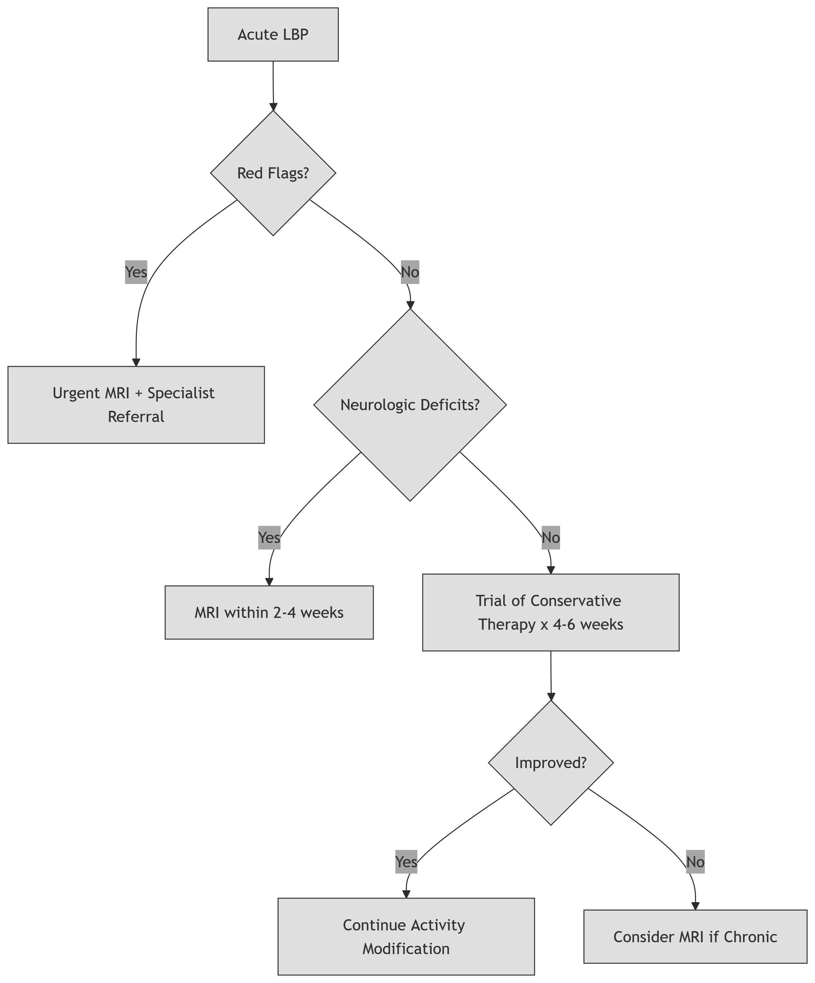

##### ****Step 1: Red Flag Triage****

* Immediate imaging (MRI) if any red flag present.

##### ****Step 2: Neuropathic vs. Mechanical LBP****

* **Neuropathic Features (Radiculopathy)**:
  + MRI if deficits persist >4 weeks.
* **Mechanical LBP**:
  + No imaging → 6-week trial of NSAIDs + exercise.

##### ****Step 3: Refractory Pain Evaluation****

* **Imaging**:
  + X-ray if trauma/suspected fracture.
  + MRI for neurologic progression or surgical planning.
* **Laboratory Tests**:
  + CRP/ESR (infection/inflammation), HLA-B27 (spondyloarthropathy).

#### ****E. Advanced Investigations****

##### ****1. Imaging Modalities****

| ****Modality**** | ****Best For**** | ****Limitations**** |
| --- | --- | --- |
| **X-ray** | Fractures, spondylolisthesis | Poor soft-tissue resolution |
| **MRI** | Discs, nerves, tumors, infection | Overdiagnosis of asymptomatic findings |
| **CT** | Bony anatomy, stenosis | Radiation exposure |
| **CT Myelogram** | Nerve root compression | Invasive; risk of headache |

##### ****2. Specialized Tests****

* **Electromyography (EMG)**:
  + Differentiates radiculopathy from peripheral neuropathy.
* **Diagnostic Nerve Blocks**:
  + Facet joint/SI joint injections to confirm pain source.

#### ****F. Psychosocial Assessment Tools****

* **Örebro Musculoskeletal Pain Questionnaire**: Predicts chronicity.
* **Waddell Signs** (Non-organic Pain Indicators):
  + Superficial tenderness, simulation tests, overreaction.
  + ≥3 signs suggest psychosocial contribution.

### ****Key Takeaways****

1. **History/Exam are Foundation**: 90% of diagnoses derive from clinical assessment.
2. **Red Flags Demand Speed**: Cauda equina requires MRI within 12 hours.
3. **Avoid Premature Imaging**: No benefit in absence of neurologic deficits.
4. **Psychosocial Factors are Prognostic**: Screen early in subacute/chronic LBP.

#### ****V. Treatment****

##### ****A. Nonspecific LBP****

* **Pharmacotherapy**: NSAIDs (first-line), short-term muscle relaxants.
* **Non-Pharmacologic**: Exercise therapy, spinal manipulation, heat therapy.
* **Avoid**: Bed rest (delays recovery), traction, TENS.

##### ****B. Herniated Discs****

* **Conservative**: NSAIDs, epidural corticosteroids (short-term relief), McKenzie exercises.
* **Surgical Indications**: Cauda equina syndrome, progressive neurologic deficits, refractory pain >1 month.
  + Procedures: Microdiscectomy (gold standard), endoscopic discectomy.

##### ****C. Chronic LBP****

* Exercise: Aerobic conditioning + core strengthening.
* Yoga (Viniyoga, Iyengar): Reduces pain intensity.
* Antidepressants (e.g., duloxetine) for comorbid depression.

##### ****D. Inflammatory/Systemic Causes****

* Ankylosing spondylitis: TNF-α inhibitors (e.g., infliximab).

#### ****VI. Prognosis****

* **Acute LBP**: 70% recover within 3 weeks; 40% recur within 6 months.
* **Chronic LBP**: Rarely permanently disabling; multidisciplinary care optimizes function.

#### ****VII. Prophylaxis****

1. **Exercise**: Aerobic + lumbar stabilization (e.g., Pilates).
2. **Ergonomics**: Lifting technique training, workplace modifications.
3. **Lifestyle**: Weight management, smoking cessation.
4. **Psychosocial**: Stress reduction, cognitive-behavioral therapy.

### ****MCQ Self-Assessment****

1. **Low back pain is most commonly caused by:**
   1. Herniated discs
   2. Musculoligamentous strain
   3. Spinal tumors
   4. Ankylosing spondylitis
2. **A positive straight leg raise test is defined by pain below the knee at:**
   1. <30° elevation
   2. <60° elevation
   3. 75° elevation
   4. Any elevation
3. **Imaging for acute LBP is immediately indicated in:**
   1. All patients
   2. Sciatica lasting 1 week
   3. Suspected cauda equina syndrome
   4. Obesity
4. **First-line pharmacotherapy for nonspecific LBP is:**
   1. Opioids
   2. NSAIDs
   3. Anticonvulsants
   4. Muscle relaxants
5. **Which nerve root is most commonly compressed in disc herniation?**
   1. L4
   2. L5/S1
   3. T12
   4. S2
6. **Bed rest for acute LBP is:**
   1. Recommended for 1 week
   2. Harmful to recovery
   3. Effective for pain control
   4. Necessary for sciatica
7. **Cauda equina syndrome includes all EXCEPT:**
   1. Saddle anesthesia
   2. Urinary frequency
   3. Unilateral foot drop
   4. Anal sphincter laxity
8. **Preventive strategies for LBP include:**
   1. Prolonged sitting
   2. Smoking cessation
   3. Avoiding exercise
   4. High-heeled shoes
9. **Chronic LBP management should prioritize:**
   1. Bed rest
   2. Opioid monotherapy
   3. Multidisciplinary rehabilitation
   4. Serial MRI scans
10. **Ankylosing spondylitis is characterized by:**
    1. Pain worsening with activity
    2. HLA-B27 negativity
    3. Morning stiffness improving with rest
    4. Female predominance

**Answers**: 1b, 2b, 3c, 4b, 5b, 6b, 7c, 8b, 9c, 10c

### ****References****

1. Hoy D et al. Best Pract Res Clin Rheumatol. 2010;24(6):769-81
2. Maher C et al. Lancet. 2017;389(10070):736-47
3. Deyo RA et al. JAMA. 2013;309(8):771-2
4. Bogduk N. Clinical Anatomy of the Lumbar Spine. 6th ed. Elsevier; 2022
5. Kalichman L et al. Spine. 2009;34(21):E798-E802
6. Haig AJ et al. Arch Phys Med Rehabil. 2013;94(6):1020-5
7. Elmasry S et al. JOR Spine. 2021;4(2):e1168
8. Chou R et al. Ann Intern Med. 2007;147(7):478-91
9. Sieper J et al. Nat Rev Dis Primers. 2015;1:15001
10. NICE Guidelines [NG59]. Low back pain and sciatica in over 16s: assessment and management. 2023 update
11. Qaseem A et al. Ann Intern Med. 2017;166(7):514-30
12. Van den Bosch M et al. Eur Spine J. 2022;31(12):3387-95
13. Finucane LM et al. Eur Spine J. 2020;29(8):1865-74
14. Manchikanti L et al. Pain Physician. 2020;23(3S):S1-S127
15. Juch J et al. Pain. 2017;158(12):2321-30
16. Davis KG et al. IISE Trans Occup Ergon Hum Factors. 2021;9(1):1-14